Penumbra

📘 Definition
# Source: AI Source: Provided by: [Data Path: Persons Table -> ID Column: 1, Name_En Column: Motasem Essam] -> From: [ChatGPT] on [5/2/2026]
The Penumbra is the lighter, outer part of a shadow where the light is only partially blocked by an object. Unlike the umbra (total darkness), the penumbra is faint and blurry.

🌗 How penumbra forms
# Source: AI Source: Provided by: [Data Path: Persons Table -> ID Column: 1, Name_En Column: Motasem Essam] -> From: [ChatGPT] on [5/2/2026]
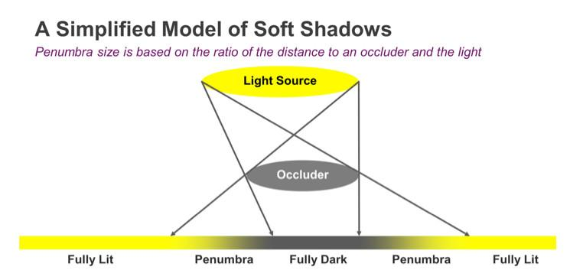
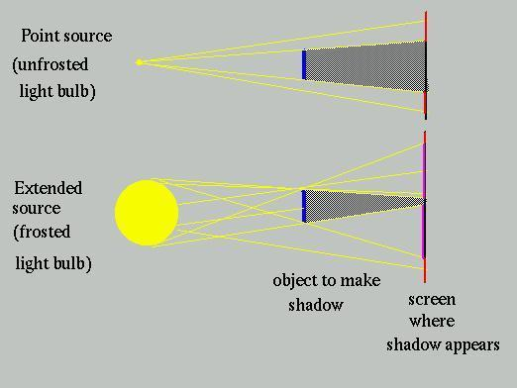
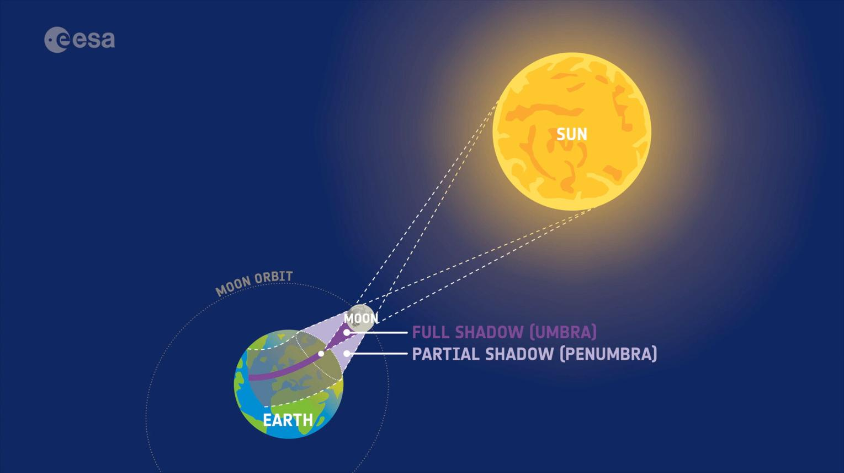
- Light is partially blocked
- Some light still reaches the area
- Creates a soft, light shadow region

🧠 Simple example
# Source: AI Source: Provided by: [Data Path: Persons Table -> ID Column: 1, Name_En Column: Motasem Essam] -> From: [ChatGPT] on [5/2/2026]
Think of:
- 🌘 A solar eclipse → the lighter outer shadow around the center is the penumbra
- ☀️ Your shadow → the faded edges around the dark center

🌍 Penumbra in real life
# Source: AI Source: Provided by: [Data Path: Persons Table -> ID Column: 1, Name_En Column: Motasem Essam] -> From: [ChatGPT] on [5/2/2026]
- During a solar eclipse, people in the penumbra see a partial eclipse
- In everyday life, it is the blurred edge of a shadow

⚙️ Key features
# Source: AI Source: Provided by: [Data Path: Persons Table -> ID Column: 1, Name_En Column: Motasem Essam] -> From: [ChatGPT] on [5/2/2026]
- 🌫️ Light gray or faint shadow
- 📍 Found around the umbra
- 🌤️ Partial light reaches the area
- 🎯 Creates soft shadow edges

🚀 In short:
# Source: AI Source: Provided by: [Data Path: Persons Table -> ID Column: 1, Name_En Column: Motasem Essam] -> From: [ChatGPT] on [5/2/2026]
Penumbra = the lighter outer part of a shadow where light is only partially blocked.

